Name: Shubham Shashwat
Roll no.: 244CA053
DBMS Assignment 5

1. Create the following tables with the following attributes and constraints on them.
a. Bank (bk_code, bk_name, bk_address)
b. Branch (br_id, br_name, br_address, bk_code)
c. Customer (cust_ID, cust_name, phone_no, address)
d. Account (acc_no, acc_type, balance, br_id)
e. Customer_Account (cust_ID, acc_no)
f. Loan (loan_ID, loan_type, amount, br_id)
g. Customer_Loan (cust_ID, loan_ID)

1. Create all the tables by defining primary key, foreign key and other appropriate constraints.

CREATE TABLE Bank (
bk_code VARCHAR(10) PRIMARY KEY,
bk_name VARCHAR(30) NOT NULL,
bk_address VARCHAR(30) NOT NULL);
CREATE TABLE Branch (
br_id VARCHAR(10) PRIMARY KEY,
br_name VARCHAR(30) NOT NULL,
br_address VARCHAR(30) NOT NULL,
bk_code VARCHAR(10) NOT NULL,
FOREIGN KEY (bk_code) REFERENCES Bank(bk_code) ON DELETE CASCADE
);

CREATE TABLE Customer (
cust_ID NUMBER PRIMARY KEY,
cust_name VARCHAR(30) NOT NULL,
phone_no VARCHAR(20) NOT NULL,
address VARCHAR(30) NOT NULL
);

CREATE TABLE Account (
acc_no NUMBER PRIMARY KEY,
acc_type VARCHAR(50) NOT NULL,
balance NUMBER(10, 2) NOT NULL,
br_id VARCHAR(10) NOT NULL,
FOREIGN KEY (br_id) REFERENCES Branch(br_id) ON DELETE CASCADE
);

CREATE TABLE Customer_Account (
cust_ID NUMBER NOT NULL,
acc_no NUMBER NOT NULL,
PRIMARY KEY (cust_ID, acc_no),
FOREIGN KEY (cust_ID) REFERENCES Customer(cust_ID) ON DELETE CASCADE,
FOREIGN KEY (acc_no) REFERENCES Account(acc_no) ON DELETE CASCADE
);

CREATE TABLE Loan (
loan_ID NUMBER PRIMARY KEY,
loan_type VARCHAR(50) NOT NULL,
amount NUMBER(10, 2) NOT NULL,
br_id VARCHAR(10) NOT NULL,
FOREIGN KEY (br_id) REFERENCES Branch(br_id) ON DELETE CASCADE
);

CREATE TABLE Customer_Loan (
cust_ID NUMBER NOT NULL,
loan_ID NUMBER NOT NULL,
PRIMARY KEY (cust_ID, loan_ID),
FOREIGN KEY (cust_ID) REFERENCES Customer(cust_ID) ON DELETE CASCADE,
FOREIGN KEY (loan_ID) REFERENCES Loan(loan_ID) ON DELETE CASCADE
);

2. Insert atleast five records in each table.
INSERT ALL
INTO Bank (bk_code, bk_name, bk_address) VALUES ('BK01', 'State Bank of India', 'Mumbai')
INTO Bank (bk_code, bk_name, bk_address) VALUES ('BK02', 'ICICI Bank', 'Delhi')
INTO Bank (bk_code, bk_name, bk_address) VALUES ('BK03', 'HDFC Bank', 'Bangalore')
INTO Bank (bk_code, bk_name, bk_address) VALUES ('BK04', 'Axis Bank', 'Chennai')
INTO Bank (bk_code, bk_name, bk_address) VALUES ('BK05', 'Punjab National Bank', 'Kolkata')
SELECT 1 FROM dual;

INSERT ALL
INTO Branch (br_id, br_name, br_address, bk_code) VALUES ('BR01', 'Downtown Branch', 'Mumbai', 'BK01')
INTO Branch (br_id, br_name, br_address, bk_code) VALUES ('BR02', 'MG Road Branch', 'Bangalore', 'BK02')
INTO Branch (br_id, br_name, br_address, bk_code) VALUES ('BR03', 'NITK Branch', 'Surathkal', 'BK03')
INTO Branch (br_id, br_name, br_address, bk_code) VALUES ('BR04', 'Surat Branch', 'Surat', 'BK04')
INTO Branch (br_id, br_name, br_address, bk_code) VALUES ('BR05', 'Pune Branch', 'Pune', 'BK05')
SELECT 1 FROM dual;

INSERT ALL
INTO Customer (cust_ID, cust_name, phone_no, address) VALUES (101, 'Ravi Kumar', '9876543210', 'Mumbai')
INTO Customer (cust_ID, cust_name, phone_no, address) VALUES (102, 'Sita Patel', '9876543211', 'Bangalore')
INTO Customer (cust_ID, cust_name, phone_no, address) VALUES (103, 'Amit Sharma', '9876543212', 'Delhi')
INTO Customer (cust_ID, cust_name, phone_no, address) VALUES (104, 'Neha Rani', '9876543213', 'Chennai')
INTO Customer (cust_ID, cust_name, phone_no, address) VALUES (105, 'Kiran Singh', '9876543214', 'Kolkata')
SELECT 1 FROM dual;

INSERT ALL
INTO Account (acc_no, acc_type, balance, br_id) VALUES (201, 'savings', 5000, 'BR01')
INTO Account (acc_no, acc_type, balance, br_id) VALUES (202, 'current', 10000, 'BR02')
INTO Account (acc_no, acc_type, balance, br_id) VALUES (203, 'savings', 15000, 'BR03')
INTO Account (acc_no, acc_type, balance, br_id) VALUES (204, 'current', 20000, 'BR04')
INTO Account (acc_no, acc_type, balance, br_id) VALUES (205, 'savings', 3000, 'BR05')
SELECT 1 FROM dual;

INSERT ALL
INTO Customer_Account (cust_ID, acc_no) VALUES (101, 201)
INTO Customer_Account (cust_ID, acc_no) VALUES (102, 202)
INTO Customer_Account (cust_ID, acc_no) VALUES (103, 203)
INTO Customer_Account (cust_ID, acc_no) VALUES (104, 204)
INTO Customer_Account (cust_ID, acc_no) VALUES (105, 205)
SELECT 1 FROM dual;

INSERT ALL
INTO Loan (loan_ID, loan_type, amount, br_id) VALUES (301, 'Home Loan', 200000, 'BR01')
INTO Loan (loan_ID, loan_type, amount, br_id) VALUES (302, 'Personal Loan', 50000, 'BR02')
INTO Loan (loan_ID, loan_type, amount, br_id) VALUES (303, 'Vehicle Loan', 150000, 'BR03')
INTO Loan (loan_ID, loan_type, amount, br_id) VALUES (304, 'Home Loan', 300000, 'BR04')
INTO Loan (loan_ID, loan_type, amount, br_id) VALUES (305, 'Personal Loan', 100000, 'BR05')
SELECT 1 FROM dual;

INSERT ALL
INTO Customer_Loan (cust_ID, loan_ID) VALUES (101, 301)
INTO Customer_Loan (cust_ID, loan_ID) VALUES (102, 302)
INTO Customer_Loan (cust_ID, loan_ID) VALUES (103, 303)
INTO Customer_Loan (cust_ID, loan_ID) VALUES (104, 304)
INTO Customer_Loan (cust_ID, loan_ID) VALUES (105, 305)
SELECT 1 FROM dual;

3. List the details of all customers.

SELECT * FROM CUSTOMER;
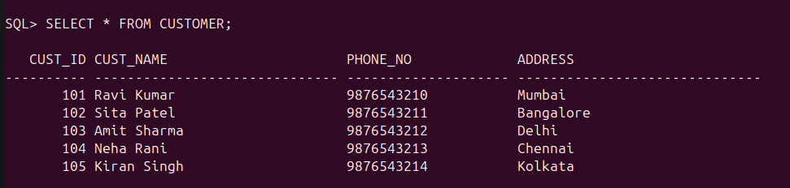

4. Find the cust_ID and phone number of customer ‘Ravi’.

SELECT CUST_ID,CUST_NAME, PHONE_NO FROM CUSTOMER
2 WHERE CUST_NAME like 'Ravi%';
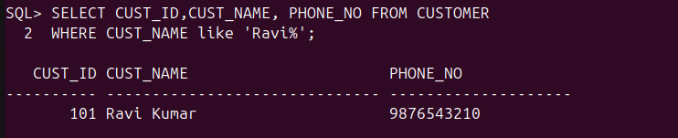
5. Find the Address of all branches of br_01.

SELECT BR_ADDRESS FROM BRANCH WHERE BR_ID='BR01';

6. Find the details of Customer having ID 103.

SELECT * FROM CUSTOMER WHERE CUST_ID= 103;
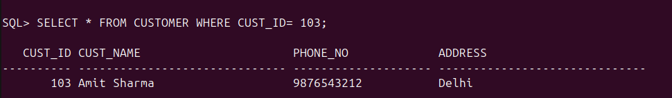
7. List the account details having balance more than 10000.

SELECT * FROM ACCOUNT WHERE BALANCE>10000;
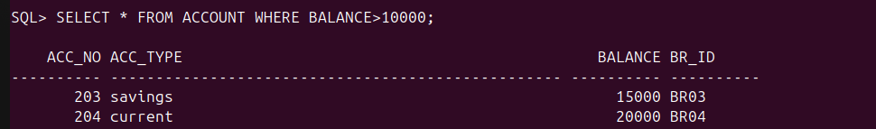
8. List the account details of branch br_02.

SELECT * FROM ACCOUNT WHERE BR_ID='BR02';
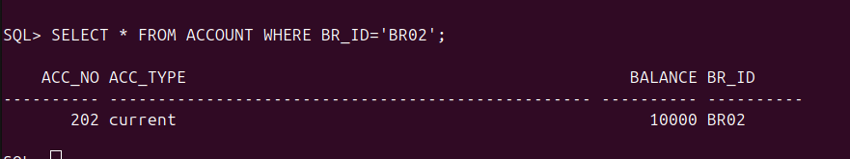
9. List the loan details of branch br_01.

SELECT * FROM LOAN WHERE BR_ID= 'BR01';
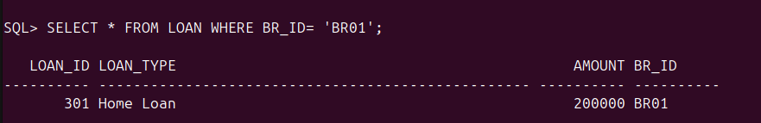

10. List the account details with their branch address.

SELECT ACC_NO, ACC_TYPE, BALANCE, A.BR_ID, B.BR_ADDRESS FROM ACCOUNT A JOIN BRANCH B ON A.BR_ID=B.BR_ID;
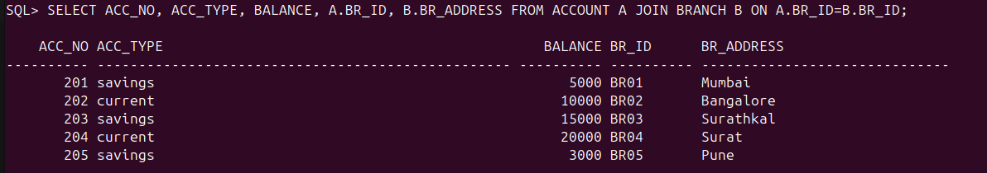
11. List the customer details with their account details.

SELECT C.CUST_ID, C.CUST_NAME, C.PHONE_NO, C.ADDRESS, CA.ACC_NO, A.ACC_TYPE, A.BALANCE,A.BR_ID
FROM CUSTOMER C JOIN CUSTOMER_ACCOUNT CA ON C.CUST_ID=CA.CUST_ID JOIN ACCOUNT A ON A.ACC_NO= CA.ACC_NO;
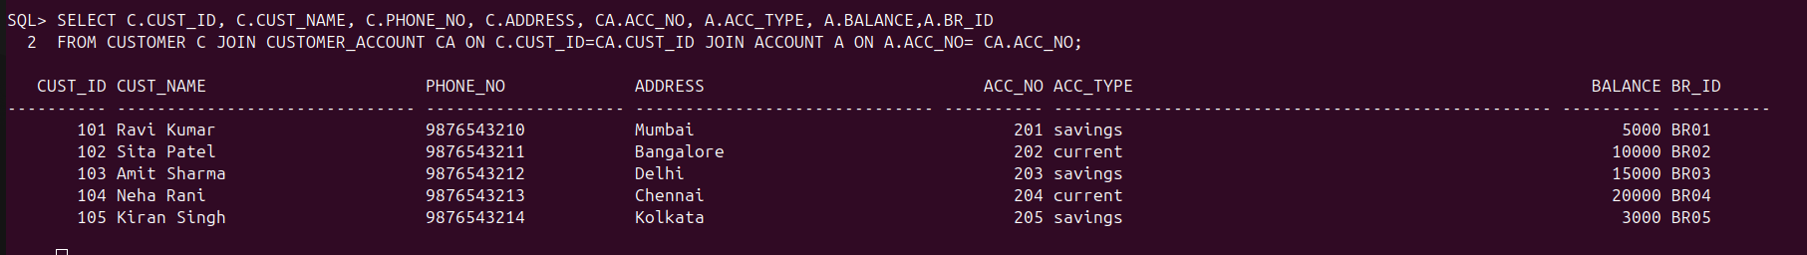

12. List the customer details having account type ‘savings’.

SELECT C.CUST_ID, C.CUST_NAME, C.PHONE_NO, C.ADDRESS, A.ACC_TYPE
2 FROM CUSTOMER C JOIN CUSTOMER_ACCOUNT CA ON C.CUST_ID=CA.CUST_ID JOIN ACCOUNT A ON A.ACC_NO= CA.ACC_NO
3 WHERE A.ACC_TYPE='savings';
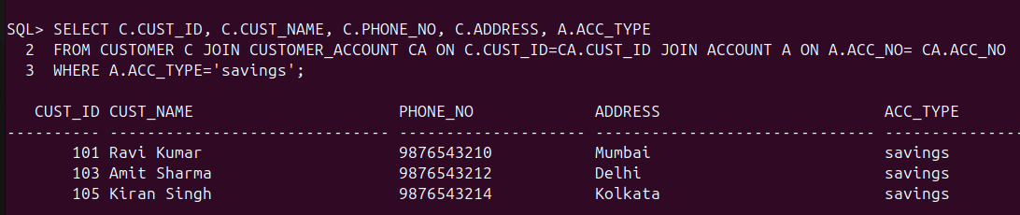

13. List the customer details having vehicle loan.

SELECT C.CUST_ID, C.CUST_NAME, C.PHONE_NO, C.ADDRESS
FROM CUSTOMER C JOIN Customer_Loan CL on C.cust_id=CL.cust_id join Loan L on L.loan_ID=CL.loan_ID where L.loan_type='Vehicle Loan';
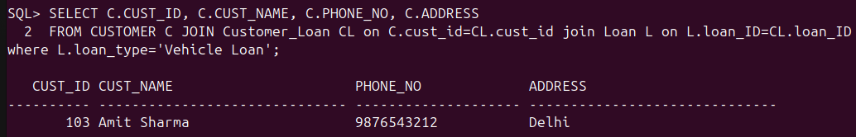
14. List the branch names of all accounts.

select A.acc_no, B.br_name from Account A join Branch B on A.br_id=B.br_id;
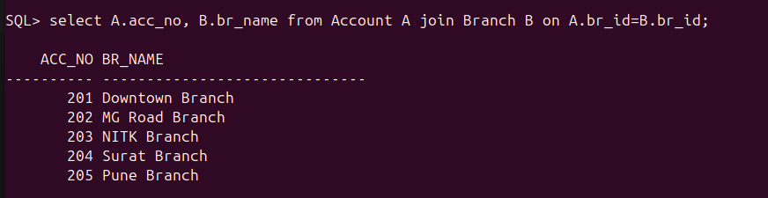
15. List the customer details going to ‘Surathkal’ branch.

SELECT C.CUST_ID, C.CUST_NAME, C.PHONE_NO, C.ADDRESS, B.br_name as Branch_name
2 from Customer C join Customer_Account CA on C.cust_ID= CA.cust_ID
3 join Account A on A.acc_no= CA.acc_no
4 join Branch B on B.br_id=A.br_id
5 where B.br_name= 'Surathkal';
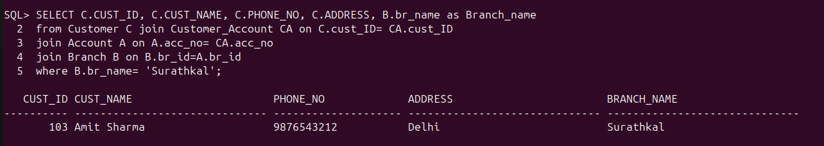
16. List the customers having loan account in ‘MG Road’ branch.

select c.cust_ID, c.cust_name, c.phone_no, c. address, b.br_name from
2 Branch b join Account a on b.br_id= a.br_id join Customer_Account ca on a.acc_no=ca.acc_no join Customer c on c.cust_ID= ca.cust_ID where b.br_name='MG Road Branch';

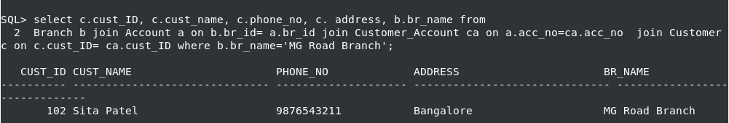

17. Find the customers having balance between 1000 to 10000 .

SQL> select c.cust_ID, c.cust_name, c.phone_no, c.address, a.balance from
2 Customer c join Customer_Account ca on c.cust_ID= ca.cust_ID join Account a on a.acc_no= ca.acc_no where a.balance>1000 and a.balance<10000;
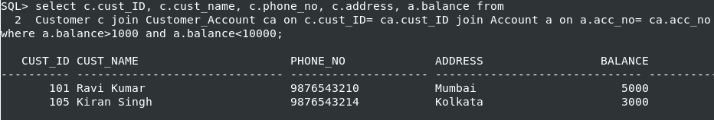
18. Give a bonus of rupees 100 to customers having more than 10000 balance.

SQL> update account set balance=balance+100
2 where balance>10000;

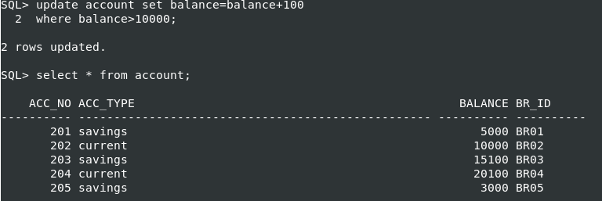
19. Deduct 50 rupees from customers having less than 500 rupees in balance.

SQL> update account set balance=balance-50
2 where balance<500;
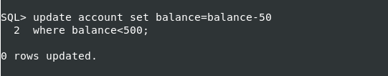
20. Give the customer details having home loan.
SQL> select c.cust_ID, c.cust_name, c.phone_no, c.address, l.loan_type
from Loan l join Customer_Loan cl on l.loan_ID= cl.loan_ID join Customer c on c.cust_ID= cl.cust_ID
where l.loan_type=’Home Loan’;
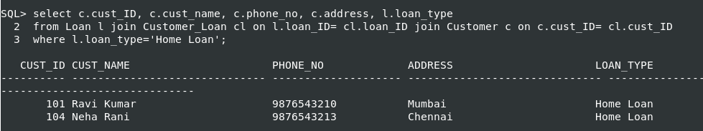
21. Give the customer details having vehicle loan in ‘NITK’ branch.

SQL> select c.cust_ID, c.cust_name, c.phone_no, c.address
2 from Loan l join Branch b on b.br_id= l.br_id join Customer_Loan cl on l.loan_ID=cl.loan_ID join Customer c on c.cust_ID= cl.cust_ID where b.br_name='NITK Branch' and l.loan_type='Vehicle Loan';

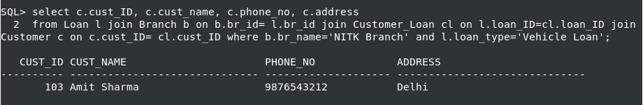

22. Add a column NOMINEE to the customer table with data type varchar (50).

SQL> alter table Customer
2 add NOMINEE varchar(50);

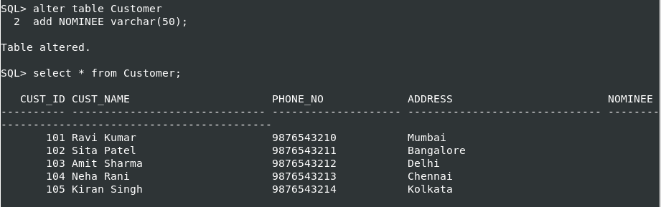
23. List all the account numbers in ascending order of their balance.

SQL> select * from account
2 order by balance;

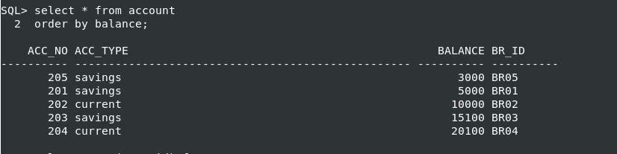

24. Count the number of customers having account type savings.

SQL> select count(acc_no) from Account where acc_type='savings';

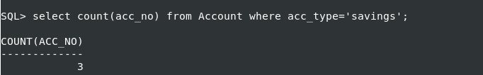

25. Count the number of customers for each account type.

SQL> select acc_type, count(acc_no) as Number_of_Accounts
2 from account group by acc_type;

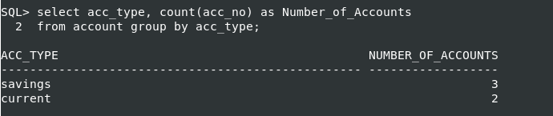
26. Find the total balance in Savings account.

SQL> select acc_type, sum(balance) as Total_Balance
2 from account where acc_type='savings'
3 group by acc_type;

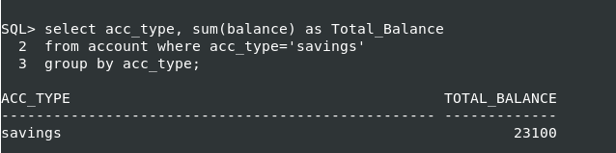
27. Find the average balance of Current account.

SQL> select acc_type, avg(balance) as Average_balance
2 from account where acc_type='current'
3 group by acc_type;
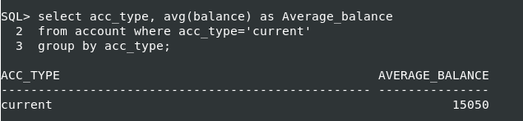

28. Find the average balance for each account type.

SQL> select acc_type, avg(balance) as Average_balance
2 from account
3 group by acc_type;

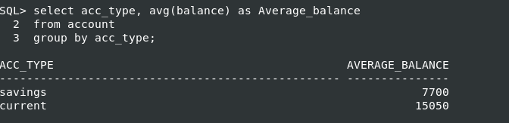

29. Find the customer details having maximum balance.

SQL> select c.cust_ID, c.cust_name, c.phone_no, c.address, a.balance
2 from Account a join Customer_account ca on a.acc_no=ca.acc_no
3 join Customer c on c.cust_ID= ca.cust_ID where a.balance =(select max(balance) from account);

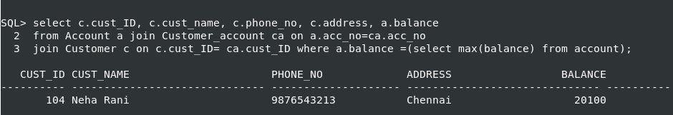

30. Find the average amount for vehicle loan.

SQL> select loan_type, avg(amount) as Average_loan from loan
2 where loan_type='Vehicle Loan'
3 group by loan_type;

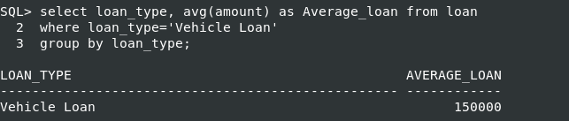

31. Find the average balance in each branch.

SQL> select b.br_name as Branch_Name, avg(a.balance) from Branch b join Account a on a.br_id=b.br_id
2 group by b.br_name;

